Guidelines for the Safe Production of Events in 2020 and Moving Forward
This document outlines the guidelines that NAME OF ORGANIZATION has set forth to produce safe and successful events in 2020 and moving forward. It is not meant to be a rigid document, but rather a living document of guidelines that will change as the pandemic evolves. This current document is dated as June 3, 2020.
Contents
Safety Measures Overview 3
Pre-Event Safety Measures 3
• Staff 3
• Exhibitor 4
During Event Safety Measures 4
Exhibitor Safety Measures 5
• General 5
• Vendor, Charity and Sponsor Specifics 5
• Restaurant Specifics 5
• Wine and Beer Specifics 6
Check-in Safety Measures 6
• Check-in Area 6
• Guest ticket sales and ticket check-in 6
• Glass Distribution 6
• Check-In Process 6
• Signage 7
• Exhibitor Check-in 7
• Exhibitor Check-in Process 7
Contracted Companies Safety Measures 8
• General 8
• Cleaning 8
• Security 8
• Tenting and Decorations 8
• Talent 9
Guest Directives 9
• Preventative practices 9
NAME OF ORGANIZATION Staff Directives 10
• General 10
• Staff Roles 11
After Event Directives 13
Form: Staff Health Screening 14
Reminders for Staff 15

Safety Measures Overview
This document is an overview of the safety precautions NAME OF ORGANIZATION will take to ensure a safe event for staff, contractors, charity partners and guests. This is not meant to be a complete list, rather an overview of some safety precautions already in place and some new precautions.
- Limiting the number of guest. Amount to be determined in collaboration with local authorities
- Eliminate lines at check-in to assure social distancing is maintained
- Expanding the layout to encourage social distancing between guests
- Plastic table coverings will be used, rather than fabric, so that the table coverings can be wiped down every 15 minutes
- Increase cleaning staff to assist in wipe down of guest tables, serving tables, clear trash from tables and event area every 15 minutes
- Requiring all NAME OF ORGANIZATION staff and volunteers to wear face coverings and gloves
- Requiring our Check-in staff to wear face coverings and gloves
- Screening staff, volunteer’s and contracted suppliers for COVID-19 symptoms prior to entering the event site
- No Tents larger than 10’ x 10’ will be used as an exhibitor activation area.
- Staffing will be assigned the duty of making sure that these guidelines are being followed by everyone involved

Pre-Event Safety Measures
In-order to create a safe event environment for our staff, Partners and guests before anyone steps into the event space, NAME OF ORGANIZATION is committed to managing pre-event safety measures. This will help mitigate the exposure risk of everyone involved.
- Staff (inclusive of NAME OF ORGANIZATION staff, Hired Production workers, check-in staff & volunteers)
  - Send Rule and Directives to all staff one week prior to event to study. Require read receipt from each individual
  - The morning of event, staff will check their own temperature and answer a series of questions before coming to event venue. FVTP staff collecting data to fill out forms for individuals and keep them on file. (see form titled: Staff Health Screening)
  - When staff arrives on site, their temperature will be taken again and logged on their individual form
  - Should a staffer have been on a cruise or traveled internationally in the previous 14 days, they will not be allowed to participate in the event
  - Should a staffer have had close contact with anyone who has been diagnosed with COVID-19 (in the prior 14 days) or are currently in close contact with someone who is showing signs of COVID-19, they will not be allowed to participate in the event
  - Should a staffer show symptoms of COVID-19 in the prior 14 days to the event, they will not be allowed to participate in the event, even if they do not have a positive test
- Exhibitor (inclusive of vendors, sponsors, restaurants, charity, wine, beer and media)
  - Emails will go out before the event that include guidelines that the exhibitors are expected to follow to ensure a safe event
  - All exhibitors will be asked to self-evaluate before coming to the event. Should they meet any of the following guidelines, they are asked not to attend the event
    - Should an exhibitor have a fever (>100.4 degrees), cough or shortness of breath
    - Should an exhibitor have been on a cruise or traveled internationally in the previous 14 days
    - Should an exhibitor have had close contact with anyone who has been diagnosed with COVID-19 (in the prior 14 days) or are currently in close contact with someone who is showing signs of COVID-19
    - Should an exhibitor show symptoms of COVID-19 in the 14 days before the event even without a positive test

During Event Safety Measures
There are many general safety measures that NAME OF ORGANIZATION will implement to produce a safe event for the guests, staff and exhibitors. These rules will be implemented by the team as a whole, rather than by an individual.
- Face coverings will be available to all staff throughout the duration of the event day
- Staff are asked to wear the masks throughout the day. Staff are required to wear their masks once the event begins
- Temperatures of staff are taken mid-way through the day and recorded on their individual forms. Temperatures should be taken after a staffer has been inside in the air conditioning for at least 20 minutes to avoid a false high temperature reading
- Should a staff member begin to display symptoms, they are required to immediately leave the premise and not return
- Hand wash stations will be stationed throughout the event so that guests and staff can wash their hands easily and often
- The staff will be responsible for making sure that the soap, water and paper towels are available. Should the wash stations run out of soap or paper towels, those will be replaced by staff. Should the wash station run out of water, it will be marked with an out of order sign and hand sanitizer will be placed on top of the station
- Hand sanitizing stations will be placed throughout the event so that staff and guests can sanitize their hands often
- Signage PLACED throughout the event promoting social distancing and good hygiene
- The tables will only be bar high (no seating) to keep people from congregating together at larger tables or sitting for long periods of time near others with whom they are not normally in close contact

Exhibitor Safety Measures

Exhibitors are an important part of the event experience for the guests. We want our guests and exhibitors to have a positive experience while also staying safe. These guidelines are to keep all in attendance safe and successful.

General
  - Emails will go out before the event that include guidelines that the exhibitors are expected to follow to ensure a safe event
  - All exhibitors will be asked to self-evaluate before coming to the event. Should they meet any of the following guidelines, they are asked not to attend the event
    - Should an exhibitor have a fever (>100.4 degrees), cough or shortness of breath
    - Should an exhibitor have been on a cruise or traveled internationally in the previous 14 days
    - Should an exhibitor have had close contact with anyone who has been diagnosed with COVID-19 (in the prior 14 days) or are currently in close contact with someone who is showing signs of COVID-19
    - Should an exhibitor show symptoms of COVID-19 in the previous 14 days before the event even without a positive test
  - Masks will be recommended but not required
  - All tables will be covered with plastic table coverings rather than fabric so that they can be easily wiped down
  - Each 10’x10’ tent will be limited to two staffers working the display

Vendor, Charity and Sponsor Specifics
  - Sponsors, vendors and charities may set their displays on their tables as they see fit
  - Tables must be set at the front of the tent so that guests do not enter the tent
  - Vendor & Sponsor must use gloves to pass any items to the guests

Restaurant Specifics
  - Tables will be set at the back of the tent and must stay in place
  - Guests may not enter the tents
  - A server will stand at the front of the tent to hand samples to the guests from a tray. This will eliminate guest touching several servings of food or utensils while trying to get their sample
  - Hand wash stations along with Rinse, Wash, Sanitize Stations will be set-up when the restaurants arrive
  - Restaurant servers will be required to wear masks and required to wear gloves

Wine and Beer Specifics
  - Tables will be set-up at the front of the tent so that guest do not enter the tent.
  - Hand wash stations and sanitizer will be set-up when the wine or beer company arrives for their use
  - Wine and beer sampling products will be poured into the guest’s tasting glass at a distance with a no-touch policy. The bottle or the can is not allowed to touch the glass
  - Beer will either be served by tap handle for kegs, poured into a serving pitcher or poured from a can. No-touch policy will apply all form of beer sample serving

Check-in Safety Measures
Check-in is the first touchpoint for guests as they enter the event. It will set the expectations for social distancing and hygiene for guests entering the event. We will convey the need to follow CDC guidelines though signage and verbal reminders.

Check-in Area
- Check-in will be set-up in a large open area that is accessible by cars (open parking lot, parking garage, etc.)
- The tables will be set with plastic table covers so that they can be wiped down every 15 minutes. Staff will be given wipes and disinfecting solution
- Staff will wear face coverings at all times
- Staff will wear gloves at all times

Guest ticket sales and ticket check-in
  - Staff will sanitize iPad/iPods between each use
  - Staff will sanitize pens between each use
  - Staff will give guests wristbands to put on themselves, though they will ask them to put them on in front of staffers before they move on to the next station
  - Staff will sanitize their gloves after each touch
- Glass Distribution
  - Glasses will be sanitized in advance and sealed in a box until they are opened for the event. The staff will open a box of glasses so that guest may reach in and retrieve their own glass. Glass boxes will be opened upside down so that the guest pulls the glass by the bottom instead of by the rim of the glass
  - Boxes that are empty will be promptly removed
  - Hand sanitizer will be available before guests get their plate or glass so that they may sanitize their hands before retrieving their plate or glass

Check-In Process
  - A staffer will stand at the entrance of an open area to welcome guests and direct them to drive their car the appropriate check-in line
  - Staffers at the check-in area will greet guests and check them in while the guest stays in their car
  - Their ID will be checked to verify age. The exhibitor check-in person will not physically touch the ID, but will look at it as the guest holds the ID. Should they need to touch the ID, the staffer will change gloves directly after touching the ID or will use sanitizer on the gloves
  - The exhibitor check-in staffer will hand the correct wristband to the guest and watch them put the wristband on
  - Once the guest is checked-in, they will drive to the parking area, park and walk into the event

Signage
  - Signage will be distributed on the event grounds and event entrance posting the guidelines for the event
    - Social Distancing Guidelines
    - Encouragement for Hygiene

Exhibitor Check-in
  - Check-in will be set-up in a large open area that is accessible by cars (open parking lot, parking garage, etc.)
  - The tables will be set with plastic table covers so that they can be wiped down and sanitized every 15 minutes. Staff will be given wipes and disinfecting solution
  - Staff will wear face coverings at all times.
  - Staff will wear gloves at all times
  - Staff will give exhibitors wristbands to put on themselves, though they will ask them to put them on in front before they move on to the next station
  - Exhibitors will be directed to the check-in location. A tent and or table will be set-up for the exhibitor to drive-up to. They will check-in from inside of their cars.

Exhibitor Check-in Process
  - Once an exhibitor arrives, an exhibitor check-in staff member will greet them. All exhibitor check-in workers will be wearing a mask and gloves.
  - The exhibitor will give the name of their business and they will be handed a map with the location of their tent.
  - Their ID will be checked. The exhibitor check-in person will not physically touch the ID, but will look at it as the exhibitor holds the ID. Should they need to touch the ID, the staffer will change gloves directly after touching the ID or will use sanitizer on the gloves.
  - The exhibitor check-in staffer will hand the correct wristband to the exhibitor and watch them put the wristband on
  - Glasses will be sanitized in advance and sealed in a box until they are opened for the event. The staff will open a box of glasses so that guest may reach in and retrieve their own glass. Glass boxes will be opened upside down so that the guest pulls the glass by the bottom instead of by the rim of the glass
  - Once the exhibitor is checked-in, they will drive to the parking area, park and unload their materials. They will walk onto the event ground to find their tent

Contracted Companies Safety Measures
To keep our staff and guests safe we will align our event business practices with businesses who also prioritize health and safety.

General
  - All hired staffing company’s employees will be asked to self-evaluate before coming to the event. Should they meet any of the following guidelines, they are asked not to attend the event
    - Should a staffer have a fever (>100.4 degrees), cough or shortness of breath
    - Should a staffer have been on a cruise or traveled internationally in the prior 14 days
    - Should a staffer have had close contact with anyone who has been diagnosed with COVID-19 (in the previous 14 days) or are currently in close contact with someone who is showing signs of COVID-19
    - Should a staffer show symptoms of COVID-19 in the 14 days prior to the event even without a positive test

Cleaning
  - We require the cleaning crew wear face coverings and gloves while on site at the event
  - Removing trash – trash will be removed promptly from the trashcans once the bags are ¾ of the way full. Trash will be transferred to the dumpster and then the staff will be asked to sanitize their gloves. There will be a sanitation station close to the dumpster for their use
  - Cleaning tables – tables will be cleared of trash when people step away from the table. Trash will be thrown in the trash bins and disinfectant will be used to wipe down the table before new guests use the table

Security
  - We require security personnel to wear face coverings and gloves while on site at the event
  - We request security personnel use Hand sanitizer as much as possible

Tenting and Decorations
  - We do not request that the tent company staff wear FACE COVERINGS during set-up, but should they be at the event site during the event, we require that they wear face covering

Talent
  - We require that the musicians to wear FACE COVERINGS during set-up and break-down of their equipment.
  - They will be 10’ away from the crowd. Their stage will be positioned to keep the crowd at least 10’ from the stage

Guest Directives
NAME OF ORGANIZATION is excited to welcome guests back to these important charity fundraising events. It is our number one priority to keep all of the staff, volunteers, charity staff, exhibitors and guests safe.
- We will have signs around the event asking guests to practice preventative actions
  - Leave events if they begin to have symptoms of COVID-19, which include fever, cough, and shortness of breath. Attendees should be encouraged to seek medical advice promptly by calling ahead to a doctor’s office or emergency room to get guidance
  - Cover coughs and sneezes with a tissue, then throw the tissue in the trash
  - Wash hands often with soap and water for at least 20 seconds, especially after going to the bathroom; before eating; and after blowing nose, coughing, or sneezing. If soap and water are not available, use hand sanitizer that contains at least 60% alcohol
  - Avoid touching eyes, nose, and mouth with unwashed hands
- The tables will only be bar high (no seating) to keep people from congregating together at larger tables or sitting for long periods of time near others with whom they are not normally in close contact
- Guests will be asked to stay at least 6’ apart from other guests with whom they are not regularly in contact
- No Children or animals (except service animals) will be allowed into the event
- Guests will be encouraged on the website ticket page as well as through marketing emails that if they fall into the greater risk category to please not purchase tickets
- Older adults and persons with severe pre-existing health conditions
- Guests will receive an email before the event with details of these directives and how the event plans to keep everyone safe

Preventative practices
- Stay home when sick, except to get medical care
- Cover coughs and sneezes with a tissue, then throw the tissue in the trash.
- Wash hands often with soap and water for at least 20 seconds, especially after going to the bathroom; before eating; and after blowing nose, coughing, or sneezing. If soap and water are not available, use hand sanitizer that contains at least 60% alcohol
- Avoid touching eyes, nose, and mouth with unwashed hands.
- Clean frequently-touched surfaces and objects daily
- Handshakes and “high-fives” are often exchanged at events, and these can be ways in which COVID-19 can be transmitted from person to person. Elbows or thumbs up are encouraged to greet neighbors and friends

NAME OF ORGANIZATION clearly identify each staff person’s role, responsibilities, and decision-making authority. The rules and regulations in regard to the staff working the event will also be updated regularly to make sure it reflects the most current safety and health information GUIDELINES

General
  - All staff members will be requested to wear face coverings during set-up except in the case of the following, for which staff are required to wear a mask:
    - Working with glasses
    - Working to set-up restaurant sanitation stations
    - Working with table covers
    - All staff will be required to wear face coverings during the event
  - Masks or face coverings will be made available for the staff to use. Staff will be allowed to bring in their own
  - Staff will not be required to wear gloves during set-up of the event except in the case of the following, for which staff are required to wear a mask:
    - Working with glasses
    - Working to set-up restaurant sanitation stations
    - Working with table covers
  - All staff will be required to wear gloves during the event
  - Disposable plastic gloves will be available for staff to use and switch out often.
  - Staff will be asked to wash their hands or use hand sanitizer often throughout the set-up and duration of the event
  - Temperatures of staff are taken mid-way through the day and recorded on their individual forms. Temperatures should be taken after a staffer has been inside in the air conditioning for at least 20 minutes to avoid a false high temperature reading
  - Should a staff member begin to display symptoms, they are required to immediately leave the premise and not return. The health department will be notified
  - The morning of event, all staff will check temperatures, and answer a series of questions before coming to event venue. NAME OF ORGANIZATION staff collecting data will fill out forms for individuals and keep them on file. (see form titled: Staff Health Screening-page 15)
  - When staff arrives on site, their temperature will be taken again and logged on their individual form
  - Should a staffer have been on a cruise or traveled internationally in the previous 14 days, they will not be allowed to work the event
  - Should a staffer have had close contact with anyone who has been diagnosed with COVID-19 (in the prior 14 days) or are currently in close contact with someone who is showing signs of COVID-19, they will not be allowed to work the event
  - Should a staffer show symptoms of COVID-19 in 14 days prior to the event, they will not be allowed to work the event, even if they do not have a positive test

Staff Roles
  - NAME
    - Top Decision-Making Authority
    - Production Manager
  - NAME
    - Top Decision-Making Authority
    - Sponsor, charity, media, winery and brewery relations
    - Production Co-Manager
  - NAME
  - Decision-Making Authority. Must run large decision by NAME
    - Production Staff Manager
    - Liaison to hired companies
    - Work with the Health and Safety Manager to make sure everyone on-site is complying with all directives set forth in this document.
  - NAME
    - Stage Manager
    - Must run all medium to large decisions by SUPERVISORS
  - NAME
    - Health Department Contact
    - Managing the set-up of food serving stations with rinse, wash, sanitize stations and hand wash stations that are inside of tents
    - Manager of restaurant directives. Makes sure that the restaurants understand the directives and follow them
  - Has the authority to ask someone to comply with the regulation. Should the person choose not to comply with the directives as requested, NAME will ask for SUPERVISORS to review and help manage the situation as needed
  - Health and Safety Manager
    - This person will manage the beforehand and one-site staff health and safety regulations. This will include but is not limited to:
      - Managing the Staff Health Screening forms
      - Making sure that the staff is complying with the directives laid out in this document
      - Making sure that the CONTRACTOR hired companies are complying with the directives laid out in this document
      - Making sure that the exhibitors are complying with the directives laid out in this document
    - Has the authority to ask someone to comply with the regulation. Should the person choose not to comply with the directives as requested, this manager will ask for SUPERVISORS to review and help manage as needed
  - NAME
    - Volunteer Coordinator
    - Manager of volunteer relations and directives. Makes sure that the volunteers understand and follow the directives
    - Managing the Staff Health Screening forms for the volunteers
  - Has the authority to ask someone to comply with the regulation. Should the person choose not to comply with the directives as requested, NAME has the authority to remove a volunteer from a post and reassign them or ask them to leave the event

After Event Directives
NAME OF ORGANIZATION commitment to safety does not end when the event is over. We are committed to supporting our community through follow-up actions after the event is over.
- NAME OF ORGANIZATION will follow up with our staff in the three weeks following the event to check-in and see if any symptoms have arisen in any of the staff members. Should a staff member have symptoms or test positive for COVID-19, NAME OF ORGANIZATION will notify the proper health authorities
- NAME OF ORGANIZATION will follow up with the event guests through an email survey sent to the ticket-purchasers to see if any of the ticket-purchasers or the guests for which they purchased tickets have had symptoms arise or test positive. Should a guest have symptoms or positive test results, NAME OF ORGANIZATION will notify the proper health authorities

Form: Staff Health Screening

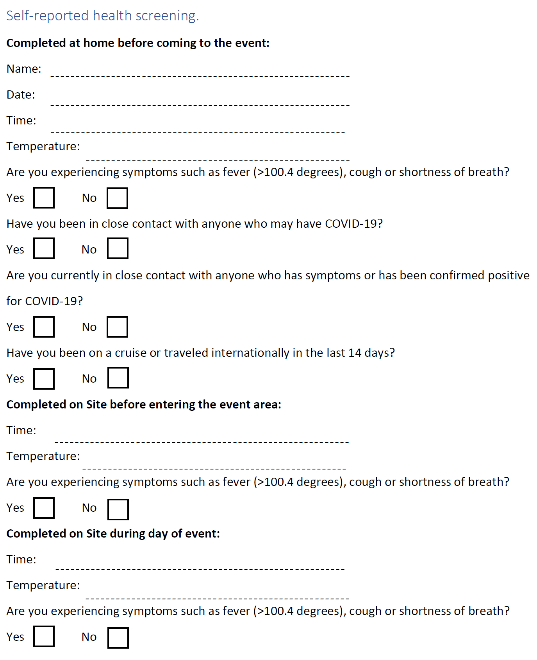

Reminders for Staff
To be printed and placed prominently in the staff staging area
- We request that you wear face covering during set-up except in the case of the following, then you MUST wear a face covering:
  - Working with glasses
  - Working to set-up restaurant sanitation stations
  - Working WITH table covers
- All staff are required to wear face coverings during the event.
- Face coverings are available for the staff to use. You may wear your own if you wish.
- You are not requested to wear gloves during set-up of the event except in the case of
  - Working with glasses
  - Working to set-up restaurant sanitation stations
  - Working with table covers
- You are required to wear gloves during the event.
- Disposable plastic gloves are available for the staff’s use and to switch out often
- Please wash hands or use hand sanitizer often throughout the set-up and duration of the event
- Staff temperatures will be taken mid-way through the day and recorded on their individual forms. Temperatures should be taken after team member has been inside in the air-conditioning for at least 20 minutes to avoid a false high temperature reading. The health and safety manager will record the readings on the health screening form.
- Should you begin to display symptoms, you are required to immediately leave the premise and not return. The health department will be notified.

